Myrtle Beach RV Resort

NEWSLETTER

October 2024

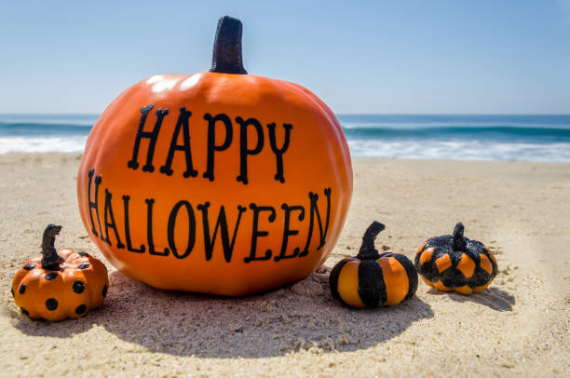
Community News:
*Welcome to our new Residents (263)
*Invoices for fourth quarter have gone out and are due October 1st
*We are still looking for volunteers for the ARB
Friendly Reminders:
*All ARB requests must be approved by the ARB prior to getting a permit from the City of North Myrtle Beach.
*Motorized watercraft is not allowed in the park, unless it is going to the maintenance building to be stored.
*Items stored by the maintenance building need to have a lot number on them and be registered at the Office. There are forms and tags in the mailbox attached to the side of the maintenance building.
*Please be a responsible pet owner and keep your animals on a leash and PICK UP after them.
*Please do not in any capacity go down to the FFA marsh access if it says closed.
Closed October 3-6th, 10-13th, 17-20th
24-30th
*Quiet hours are from 11pm-7am
* Please use cardboard dumpster for boxes
*Please keep in mind the speed limit in the park is 15mph

Contact Information:
(843) 249-1484 Phone
(843) 249-1484 Fax
myrtlebeachrv@gmail.com
www.mbrvresorthoa.com
Facebook-Myrtle Beach RV Resort Members Group
Office Hours:
Monday-Friday 8:30am-4:30pm
Closed for lunch from 1pm-2pm

Upcoming Events:

October 1st
Invoices are due

October 31st
Halloween

October 31st
Pools & hot tub close
for the season

*Monitor your thoughts*
“Notice the negative ones and consciously REPLACE them with positive ones"

“Clothes make a statement. Costumes tell a story.”

Mason Cooley

